

Karunakar Naidu



BY
Table of Contents
- Overview 2
- Abstract 3
- Introduction 4
3.1 Brief History of Apache Phoenix 4
3.2 What is Apache Phoenix? 4
3.3 Need for Apache Phoenix? 4
4. Architecture 5
4.1 Quick overview of HBase 5
4.2 Phoenix Architecture 6
5. Phoenix Configuration 7
5.1 Generic Installation 7
5.2 Installation on CDH 7
5.3 Configuration for secondary indexing 8
5.4 Smoke testing Phoenix 8
6. Phoenix Data Model 9
6.1 SQL Support 9
6.2 Schema 9
7. Key Features of Apache Phoenix 11
7.1 Views 11
7.2 Dynamic columns 11
7.3 Multi-Tenancy 12
7.4 Joins 12
7.5 Salted Tables 12
7.6 Subqueries 13
7.7 Skip Scans 13
7.8 Bulk CSV Data Loading 13
8. Performance 15
9. Who uses Apache Phoenix 17
10. Conclusion 18
11. Appendix 19
12. References 19

1. Overview
The intention of this document is to provide detail regarding what is Apache Phoenix, need for Apache Phoenix and how it can be used in Hadoop eco system. This document also includes how Apache Phoenix can be installed in your existing cluster and its features. The documentation was written in view of target readers/audience with knowledge of core Hadoop and its components (Hands on experience with HBase, SQL is added advantage).

2. ABSTRACT
Apache Phoenix is an open source, massively parallel, SQL skin for HBase. We can use the standard JDBC APIs instead of the regular HBase client APIs to create tables, insert data, and query our HBase data. Phoenix began as an internal project by the company salesforce.com out of a need to support a higher level, well understood, SQL language, it was developed in 100% JAVA. It was originally open-sourced on GitHub and became a top level Apache project on 22 May 2014. Apache Phoenix is included in the Hortonworks distribution for HDP 2.1 and above, is available as part of Cloudera labs, and is part of the Hadoop ecosystem. It’s a complete relational system, delivered as JDBC driver, uses HBase APIs instead of Map/Reduce, reintroduces the familiar declarative SQL interface to data (DDL,DML, etc.) with additional benefits such as read only views on existing HBase data, reintroduces typed data and query optimizations possible with it, secondary indexes, query optimizations etc. Phoenix integrates the scalable HBase data storage platform as just another JDBC data source. Accessing HBase data with Phoenix can be substantially faster than direct HBase API use. Phoenix parallelizes queries based on stats where HBase does not know how to chunk the queries beyond scanning an entire region, it supports and uses secondary indexes and Joins (limited as of now). In Phoenix columns modelled as multi-part row key and key values. Phoenix brings computation to the data. Many companies like Intuit, Dell, Huawei, Alibaba.com etc. are using Phoenix.

3. Introduction

Brief History of Apache Phoenix

Phoenix initially started as an internal project at Salesforce.com to efficiently analyse big data stored in HBase. It was open sourced on GitHub in Jan 2013 and became a top level Apache project on 22 May 2014.Phoenix's developer community has also grown to include additional companies such as Intel, who have contributed join support to Phoenix, as well as Hortonworks, Cloudera.

3.2 What is Apache Phoenix?
Apache Phoenix is a Relational database layer over HBase that allows developers to write SQL queries to answer questions against very large data sets. HBase is a distributed, horizontally scalable key value store that persists its data in the Hadoop Distributed File System (HDFS). Phoenix allows a developer to express queries in familiar SQL, and then executes those queries extremely quickly. Phoenix works differently than many other SQL layers on Hadoop by actually compiling down to native HBase client calls.
3.3 Need for Apache Phoenix

Hive is added into Hadoop Eco-system to maintain and manage structured data in Hadoop and it also provide an SQL like dialect to query the tables in Hive data warehouse. But hive doesn’t provide record level operations such as insert, update and delete operations.

To overcome this drawback of hive, HBase is brought into Hadoop eco-system to support record level operations. But HBase shell supports only HBase commands such as ‘scan’, ‘get’, ‘put’, ‘list’ to query entire table, to get a row and listing tables etc. respectively. Thus HBase introduced its own set of commands and doesn’t support SQL interface.

Phoenix is introduced into Hadoop Eco System to provide an SQL Layer on top of HBase. Phoenix provides very high performance when compared to Hive and cloudera Impala.

4. ARCHITECTURE

4.1 Quick overview of HBase

HBase is an open source, non-relational, distributed database modelled after Google's Big Table and written in Java. It is developed as part of Apache Software Foundation's Apache Hadoop project and runs on top of HDFS (Hadoop Distributed Filesystem), providing Big Table-like capabilities for Hadoop.

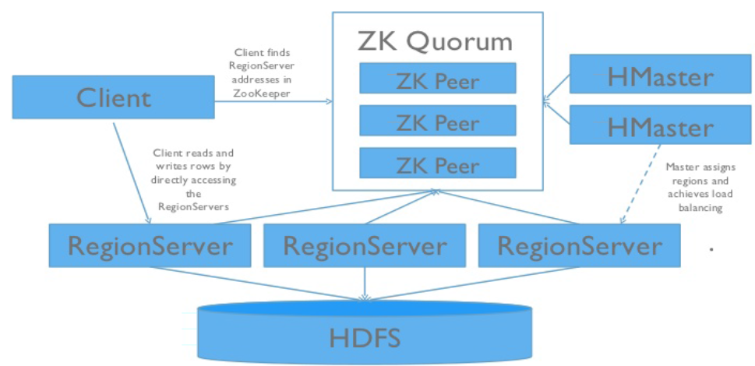

Figure 4-1: showing HBase cluster in Hadoop

4.2 Phoenix Architecture

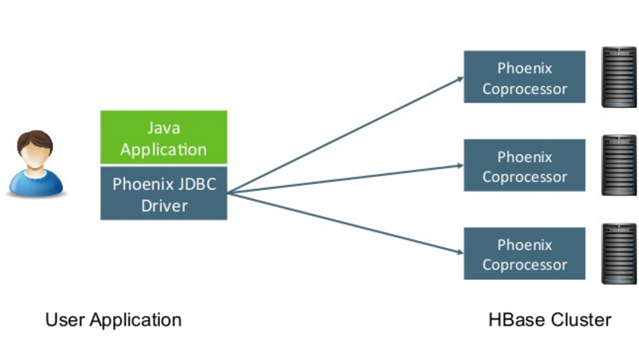
Figure 4-2.1: showing Phoenix Architecture
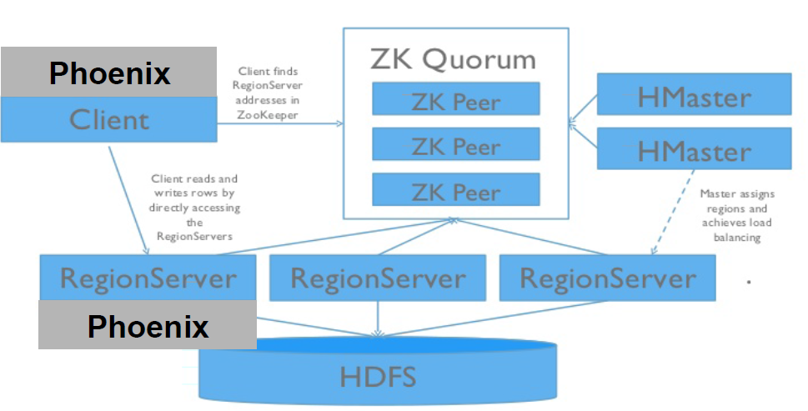
Figure 4-2.2: showing Phoenix on HBase cluster

5. Phoenix configuration
5.1 Generic Installation
Different Phoenix versions are compatible with different HBase versions. In this documentation we used Phoenix 3.0.0 with HBase 0.94, the Hadoop distribution was Cloudera CDH4.4 with Hadoop v1.The Phoenix package contains both Hadoop version 1 and version 2 drivers for the clients so we had to use the appropriate Hadoop-1 files. Below is version compatibility matrix:

Phoenix 3.x – HBase 0.94.x
Phoenix 4.x – HBase 0.98.1 +
    - Download and unzip the downloaded Phoenix package:
$ tar -xf phoenix-3.0.0-incubating.tar.gz
    - Add the phoenix-3.0.0-incubating-client-minimal.jar and the phoenix-core-3.0.0-Incubating.jar files to class path of every HBase region server:

$ cd ~/phoenix/phoenix-3.0.0-incubating/common

$ cp phoenix-3.0.0-incubating-client-minimal.jar /usr/lib/hbase/lib

$ cp phoenix-core-3.0.0-incubating.jar /usr/lib/hbase/lib

    - Restart all of the HBase region servers.

    - Phoenix provides a command line tool called sqlline – it is a utility written in Python. Its functionality is similar to Oracle SQLPlus or MySQL command line tools.

$ ./sqlline.py localhost

  - Installation on CDH
The Phoenix package is currently distributed only as a parcel hence before installing this in CDH distributed (5.4.x) cluster follow the below steps:
    - Shutdown HBase
- $ sudo service hbase-thrift stop.
- $ sudo service hadoop-hbase-regionserver stop.
- $ sudo service hbase-master stop.

    - In cloudera manager go to HostsParcelsSelect edit settings.

    - Click the + sign next to an existing Remote Parcel Repository URL, and add the appropriate URL (https://archive.cloudera.com/cloudera-labs/phoenix/parcels/1.1 or https://archive.cloudera.com/cloudera-labs/phoenix/parcels/1.2) Click Save Changes.
Here 1.1 indicates this parcel is for Hadoop version1 and 1.2 for Hadoop version 2.

    - Select HostsParcelsCLABS_PHOENIX and click download.

    - The first cluster is selected by default. To choose a different cluster for distribution, select it, find CLABS_PHOENIX in the list, and click Distribute.

    - Start HBase.

    - To start Phoenix from Shell type:

$ phoenix-sqlline.py <host> : <port>

Or in local mode type:

$ phoenix-sqlline.py localhost: 2181

  - Configuration for secondary indexing
To use secondary indexing feature of Apache Phoenix we need to add following property to hbase-site.xml. For this we need to select HBase service Configuration HBase Service Advanced Configuration Snippet for hbase-site.xml:
<property>
<name>hbase.regionserver.wal.codec</name>
<value>org.apache.hadoop.habse.regionserver.wal.IndexedWALEditCodec</value>
</property>

  - Smoke testing Phoenix

5.4.1 From CLI run following commands (specify the Apache ZooKeeper quorum of the corresponding HBase cluster):

$ phoenix-sqlline.py zookeeper.local for LOCAL MODE.

$ phoenix-sqlline.py zk01.example.com:2181 for DISTRIBUTED MODE.

If you have successfully installed phoenix, then on the screen we can see message saying:

$ phoenix-sqlline.py zookeeper.local
Connected to: Phoenix (Version 4.5.2)
Driver: PhoenixEmbeddedDriver (Version 4.5.2)
Autocommit status: true
…………………………………………………………….
……………………………………………………………..
Done

$ jdbc:phoenix:zookeeper.local>

5.4.2 Additionally we can issue SQL commands or Phoenix commands.

6. Phoenix Data Model

Phoenix maps the HBase data model to the relational world.

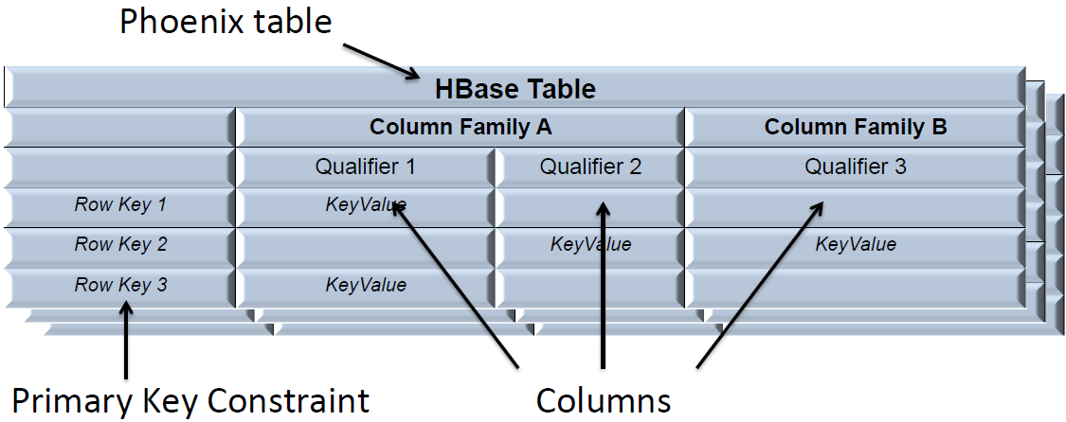

Figure 6-1.1: showing Phoenix mapping to HBase data model

6.1 SQL Support
Phoenix includes all typical SQL query statement clauses, including SELECT, FROM, WHERE, GROUP BY, HAVING, ORDER BY, etc. It also supports a full set of DML commands as well as table creation and versioned incremental alterations through our DDL commands.
6.2 Schema
A Phoenix table is created through the CREATE TABLE DDL command and can either be:
6.2.1 Built from scratch
In this case the HBase table and column families will be created automatically.
6.2.2 Mapped to an existing HBase table
By creating either a read-write TABLE or a read-only VIEW, with the caveat that the binary representation of the row key and key values must match that of the Phoenix data types.

For a read-write TABLE, column families will be created automatically if they don’t already exist. An empty key value will be added to the first column family of each existing row to minimize the size of the projection for queries.
For a read-only VIEW, all column families must already exist. The only change made to the HBase table will be the addition of the Phoenix coprocessors used for query processing. The primary use case for a VIEW is to transfer existing data into a Phoenix table, since data modification are not allowed on a VIEW and query performance will likely be less than as with a TABLE.

Ex: In HBase we create a table as below:
create 't1', {NAME => 'f1', VERSIONS => 5}
In Phoenix we create table to the existing HBase table as below:
CREATE VIEW t1 ( pk VARCHAR PRIMARY KEY, f1.val VARCHAR )
All schema is versioned, and prior versions are stored forever. Thus, snapshot queries over older data will pick up and use the correct schema for each row.

7. Key Features of Apache Phoenix
7.1 Views
Views are supported by phoenix to enable multiple virtual tables to all share the same underlying physical HBase table.
Ex: CREATE VIEW mobile_product_metrics (carrier VARCHAR, dropped_calls BIGINT)
AS SELECT * FROM product_metrics
WHERE metric_type = 'm';
In this case Underlying HBase tables (PRODUCT_METRICS) stores all of the data.
7.1.1 Updatable Views
Views created using only simple equality expressions in the where clause are updatable.
Ex: UPSERT INTO mobile_product_metrics(created_by, create_date, metric_id, carr
ier, dropped_calls)
VALUES ('John Doe', CURRENT_DATE(), NEXT VALUE FOR metric_seq,'Verizon',20);
7.1.2 Read-only Views
Views created using complex WHERE clauses in the view definition will result in read only views. Native HBase tables can be mapped with read-only views.
7.2. Dynamic Columns
Sometimes defining a static schema up front is not feasible. Instead, a subset of columns may be specified at table create time while the rest would be specified at query time.
Ex: Existing table:
CREATE TABLE EventLog (
eventId BIGINT NOT NULL,
eventTime TIME NOT NULL,
eventType CHAR(3)
CONSTRAINT pk PRIMARY KEY (eventId, eventTime))
Query showing Dynamic columns during select statement:
SELECT eventTime, lastGCTime, usedMemory, maxMemory
FROM EventLog(lastGCTime TIME, usedMemory BIGINT, maxMemory BIGINT)
WHERE eventType = 'OOM' AND lastGCTime < eventTime – 1
Very useful for views mapped over native HBase tables.

7.3 Multi-Tenancy
Phoenix can provide multi-tenant isolation via a combination of multi-tenant tables and tenant –specific connections.
- Tenant specific connections only access data that belongs to the tenant.
- Tenants can create tenant specific views and add their own columns.
7.3.1 Multi-Tenant Tables
These tables can be created by declaring the DDL property MULTI_TENANT=true
Ex: CREATE TABLE event (
tenant_id VARCHAR, First Pk column identifies the tenant ID
type CHAR(1),
event_id BIGINT,
created_date DATE,
created_by VARCHAR,
CONSTRAINT pk PRIMARY KEY (tenant_id, type, event_id))
MULTI_TENANT=true;
7.3.2 Tenant-Specific Connections

Tenants are identified by the presence or absence of the tenantid property in the JDBC connection string. A tenant specific connection may only query:

- Their own data in multi-tenant tables.
- All data in non-multi-tenant (global) tables.
- Their own schema (Tenant specific views).

7.4 Joins

The standard SQL join syntax (with some limitations) is now supported by Phoenix to combine records from two or more tables based on their fields having common values.
Only equality is supported in joining conditions, FULL OUTER join and CROSS JOIN are not supported.

Ex: SELECT O.OrderID, C.CustomerName, C.Country, O.Date
FROM Orders AS O
INNER JOIN Customers AS C
ON O.CustomerID = C.CustomerID;
7.5 Salted tables
HBase tables can develop “hot spots” when writing data with monotonically increasing row keys. Phoenix can salt keys into N buckets such that writes fan out N-ways even with monotonic primary keys.
Ex: CREATE TABLE table (a_key VARCHAR PRIMARY KEY, a_col VARCHAR) SALT_BUCKETS = 20;
For best results N should approximate the number of region servers in the HBase cluster.

7.6 Subqueries
Phoenix now supports subqueries in the WHERE clause and the FROM clause. Subqueries can be specified in many places, like IN/NOT IN, EXISTS/NOT EXISTS, unmodified comparison operators or ANY/SOME/ALL comparison operators.
Ex1: Subqueries with IN
SELECT ItemName
FROM Items
WHERE ItemID IN
(SELECT ItemID FROM Orders WHERE Date >= to_date('2013/09/02'));

Ex2: Subqueries with EXISTS
SELECT ItemName
FROM Items i
WHERE EXISTS
(SELECT *
FROM Orders
WHERE Date >= to_date('2013/09/02')
AND ItemID = i.ItemID);
7.7 Skip Scans
Phoenix uses Skip Scan for intra-row scanning which allows for significant performance improvement over Range Scan when rows are retrieved based on a given set of keys. The optimizer identifies sub-regions of interest in the key space and chunks parallel scans by region boundaries. Within a region, column values ranges are pushed down into a filter that uses SEEK_NEXT_HINT to quickly skip through data.
7.8 Bulk CSV Data Loading
Phoenix provides two methods for loading CSV data into Phoenix tables:
- Loading via PSQL.
- Loading via MapReduce.

7.8.1 Loading via PSQL
PSQL is a single -threaded client loading tool.

Ex: CREATE TABLE mytable (
my_pk bigint not null,
m.first_name varchar(50),
m.last_name varchar(50)
CONSTRAINT pk PRIMARY KEY (my_pk))
To load data.csv into HBase running on the local machine, we run the following command:
$ bin/psql.py -t mytable localhost data.csv
(In cluster mode we specify the HBase cluster URL)
Here –t parameter implies table.
7.8.2 Loading via MapReduce
For higher-throughput loading distributed over the cluster, the MapReduce loader can be used. This loader first converts all data into HFiles, and then provides the created HFiles to HBase after the HFile creation is complete. The MapReduce loader is launched using the hadoop command with the Phoenix client jar, as follows:
$ hadoop jar phoenix-<version>-client.jar org.apache.phoenix.mapreduce.CsvBulkLoadTool --table mytable –input /example/data.csv
NOTES for MapReduce Bulk Data Loading:
- When using Phoenix 4.0 and above we should use following command
HADOOP_CLASSPATH=/path/to/hbase-protocol.jar:/path/to/hbase/conf hadoop jar phoenix-4.5.2-client.jar org.apache.phoenix.mapreduce.CsvBulkLoadTool –table mytable --input / example /data.csv
- The input file must be present on HDFS (not the local filesystem where the command is being run).
- HBase needs to have write access to the directories where the HFiles have been written. This issue can be skipped by starting the hadoop command with
$ sudo -u hbase

8. Performance
Phoenix follows the philosophy of bringing the computation to the data by using:
Coprocessors to perform operations on the server-side thus minimizing client/server data transfer
custom filters to prune data as close to the source as possible In addition, to minimize any start-up costs, Phoenix uses native HBase APIs rather than going through the map/reduce framework.
Below are charts showing relative performance between Phoenix and some other related products:
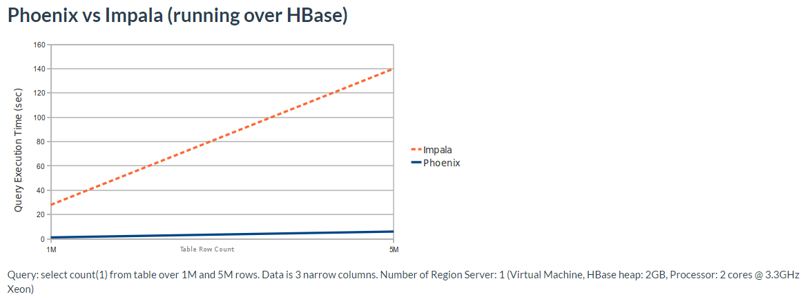
Figure 8-1: showing Phoenix vs Impala (running over HBase)

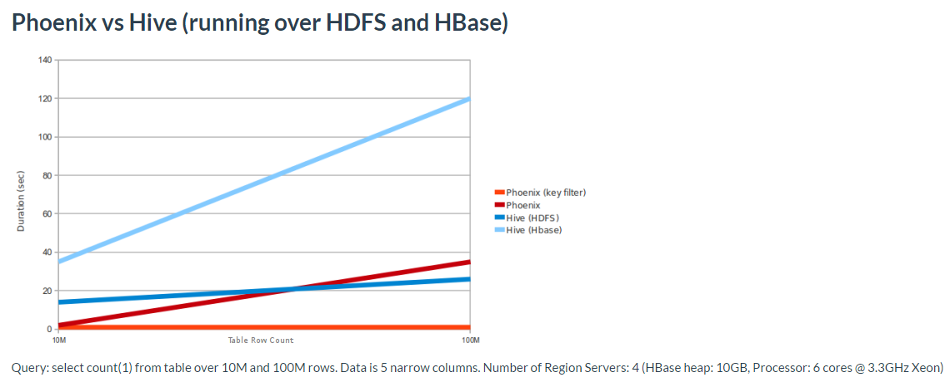
Figure 8-1: showing Phoenix vs Hive (running over HDFS and HBase)

9. Who Uses Apache Phoenix
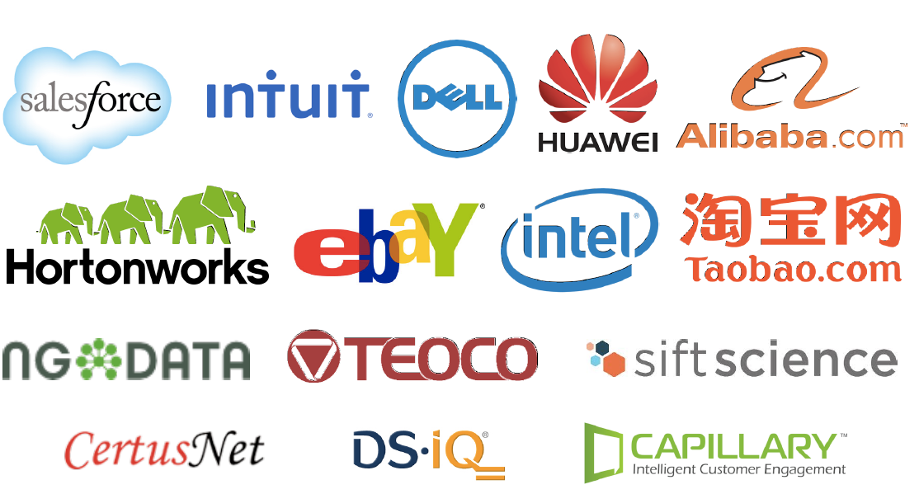

10. Conclusion
- Apache Phoenix breaks up SQL queries into multiple HBase scans and runs them in parallel.

- Phoenix is developed with notion of brining the computation to the data by using coprocessors and custom filters.

- Phoenix uses native HBase APIs rather than going through the mapreduce framework.

- Phoenix’s Skip scan filters leverages SEEK_NEXT_USING_HINT of HBase filter. It significantly improves point queries over key columns.

- Salting in Phoenix leads to both improved read and write performance by adding an extra byte at start of key and pre-splitting data in number of regions. This eliminates hot spotting of single or few region servers.

- For aggregate queries, coprocessors complete partial aggregation on their local region servers and only returns relevant data to client.

11. Appendix
- https://phoenix.apache.org/

- http://phoenix.apache.org/download.html

12. References

- https://phoenix.apache.org/

